# Media Analysis - ChatGPT is the ‘Netscape moment' for artificial intelligence'

## Short Summary

": "The article portrays ChatGPT as an AI 'Netscape moment', emphasizing its conversational capabilities but highlighting the need for advanced systems with common sense and ethical understanding to prevent misinformation, while also discussing the rise of foundation models in driving AI adoption across sectors including Saudi Arabia's strategic initiatives." }

## Summary

1. **Global Excitement Over ChatGPT**: The introduction highlights the immense public interest sparked by ChatGPT, comparing it to Netscape's impact in the 90s when it made the internet accessible.  
  
2. **Large Language Models (LLMs) and Deep Learning**: ChatGPT is built on LLMs which are artificial models trained on vast textual data using unsupervised learning techniques. These models understand word relationships, generating responses to prompts with remarkable effectiveness but lack real-world knowledge or reasoning capabilities.  
  
3. **Current Limitations of AI**: Despite their impressive performance in language understanding and generation, current AI systems struggle with common sense, logic, and ethical reasoning. They can generate plausible false information due to "hallucinations".  
  
4. **Future Evolution of AI**: As AI technology advances rapidly, it will need human-like abilities such as common sense understanding, world knowledge, ethics, and the ability to reason. These developments will help AI systems like LLMs better mimic how humans process information and make decisions.  
  
5. **Advancements in Foundation Models**: Foundation models, similar to web, mobile, or social platforms, are emerging as general-purpose technologies. They can be trained once and reused extensively, reducing computational costs significantly. These models can enhance LLMs through domain-specific data integration and application embedding.  
  
6. **AI's Role in Productivity and Labor**: AI will enable systems to perform human tasks more efficiently, potentially mitigating the burden on expensive labor. In challenging economic times due to inflation and rising costs of human labor, AI can act as a productivity lever. Long-term, it can help developed countries like Saudi Arabia address demographic challenges with aging populations and declining workforces.  
  
7. **Saudi Arabia's Strategic Position**: The article underscores that Saudi Arabia has a strategic advantage in AI due to its focus on data, technology education, investments in national AI capabilities, and the localization of LLMs into regional languages. This positions the Kingdom well for leveraging AI in various sectors like energy domain-specific knowledge integration.  
  
In conclusion, while ChatGPT exemplifies the current opportunities and limitations of AI, it also signifies a significant leap towards more human-like intelligent systems. Saudi Arabia's focus on AI aligns with global trends, positioning the Kingdom to capitalize on AI for economic sustainability and prosperity in an evolving world.

## Question 1:

How do the media in this article frame the public discussion about ChatGPT? Are there certain **metaphors** that keep cropping up?

The media in this article frames the public discussion about ChatGPT using 'Netscape moment' as a metaphor for its significant impact on AI. This comparison draws parallels to how Netscape's browser made the internet accessible globally when it was introduced in the early 1990s, symbolizing ChatGPT's revolutionary role in the field of artificial intelligence. The second metaphor used is 'rich conversational interface,' emphasizing the intuitive and interactive nature of ChatGPT by likening its responses to those provided by autocomplete but enhanced with a more sophisticated understanding of language and context. Lastly, 'generative AI tools' highlights the capabilities of these models in creating content autonomously, much like how early computers allowed users to type commands directly into their systems.

## Question 2:

Which role does or might the Arabic World play in the development of Artificial Intelligence? Answer with 'Not mentioned' if not applicable.

Exceptionally well-positioned

## Question 3:

Which use cases of Artificial Intelligence are helpful for the Arabic world based on this article?

This use case emphasizes the potential of AI in streamlining administrative processes and enhancing efficiency within the legal sector.

## Question 4:

What is the final message of the article that the author wants to convey? Keep your answer short and precise!

The author encourages rapid adoption of ChatGPT and other AI technologies for productivity enhancement and sustainable development in the face of economic pressures and demographic changes, especially emphasizing the Kingdom's potential to lead in localizing and extending AI capabilities.

## Sentiment

The sentiment is <3>

The text discusses both the remarkable capabilities and current limitations of ChatGPT, positioning it as the 'Netscape moment' for AI technology. It highlights positive applications such as automated contract creation in global law firms and potential misuse of AI-generated content. Simultaneously, the article acknowledges the need to augment these models with human-like understanding and reasoning capabilities, emphasizing their limitations like generating false or misleading information. Overall, the text conveys a balanced view of ChatGPT's potential while also cautioning about its risks. This leads to an intermediate sentiment level of +3, appreciating both the opportunities and challenges posed by AI technology.

## Entities

Focus Application Artificial Intelligence Blockchain Metaverse Technology Large, Saudi Arabia Develop Country Face Demographic Challenge, Saudi Public Private Sector Entity Encourage Explore Technology Create New Value Respective Field Industry, Chatgpt, Technologist Investment Program, Anthony Butler

## Topic Clusters

### Cluster: AI in Communication and Interaction

ChatGPT, Conversational Interface

### Cluster: AI Applications and Techniques

Deep Learning, Unsupervised Learning

### Cluster: AI Ethics and Societal Impact

Contract Creation, Plagiarism concern, Domain-specific data

### Cluster: General AI Development

Narrow AI, Data-driven advancements

## Word Clouds

### Wordcloud of content

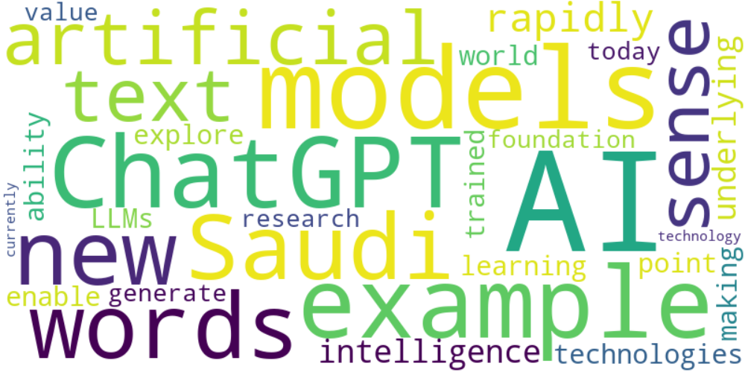

Top 10 words:

- AI: 13  
- models: 8  
- ChatGPT: 6  
- example: 6  
- new: 5  
- words: 5  
- Saudi: 5  
- artificial: 4  
- text: 4  
- sense: 4

### Wordcloud of summary

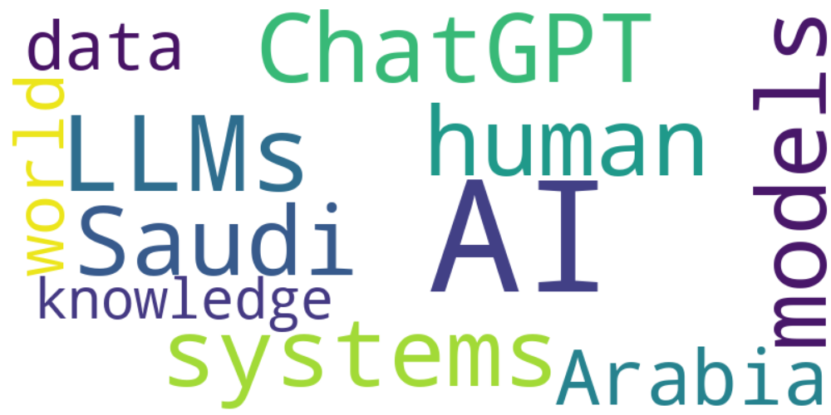

Top 10 words:

- AI: 14  
- LLMs: 5  
- like: 5  
- ChatGPT: 4  
- models: 4  
- systems: 4  
- human: 4  
- Saudi: 4  
- Arabia: 4  
- data: 3